**KRISH TEC-ARDK-PROJECTS**

**1. LED**

**CODE;**

//……………….KRISH_TEC……………………

//……………….LED.BLINK…………………….

const int ledPin1 = 13;

void setup() {

pinMode(ledPin1, OUTPUT);

}

void loop() {

digitalWrite(ledPin1, HIGH);

delay(1000);

digitalWrite(ledPin1, LOW);

delay(1000);

}

**CONNECTION;**

Not required.

**2. RGB LED INTERFACE**

**CODE;**

//……………….KRISH_TEC……………………

//……………….RGB.LED…………………….

int led1Pin1 = 1;

int led1Pin2 = 2;

int led1Pin3 = 3;

int led2Pin1 = 4;

int led2Pin2 = 5;

int led2Pin3 = 6;

int led3Pin1 = 7;

int led3Pin2 = 8;

int led3Pin3 = 9;

void setup() {

pinMode(led1Pin1, OUTPUT);

pinMode(led1Pin2, OUTPUT);

pinMode(led1Pin3, OUTPUT);

pinMode(led2Pin1, OUTPUT);

pinMode(led2Pin2, OUTPUT);

pinMode(led2Pin3, OUTPUT);

pinMode(led3Pin1, OUTPUT);

pinMode(led3Pin2, OUTPUT);

pinMode(led3Pin3, OUTPUT);

}

void loop() {

digitalWrite(led1Pin1, LOW);

digitalWrite(led1Pin2, HIGH);

digitalWrite(led1Pin3, HIGH);

digitalWrite(led2Pin1, LOW);

digitalWrite(led2Pin2, HIGH);

digitalWrite(led2Pin3, HIGH);

digitalWrite(led3Pin1, LOW);

digitalWrite(led3Pin2, HIGH);

digitalWrite(led3Pin3, HIGH);

delay(1000);

digitalWrite(led1Pin1, HIGH);

digitalWrite(led1Pin2, LOW);

digitalWrite(led1Pin3, HIGH);

digitalWrite(led2Pin1, HIGH);

digitalWrite(led2Pin2, LOW);

digitalWrite(led2Pin3, HIGH);

digitalWrite(led3Pin1, HIGH);

digitalWrite(led3Pin2, LOW);

digitalWrite(led3Pin3, HIGH);

delay(1000);

digitalWrite(led1Pin1, HIGH);

digitalWrite(led1Pin2, HIGH);

digitalWrite(led1Pin3, LOW);

digitalWrite(led2Pin1, HIGH);

digitalWrite(led2Pin2, HIGH);

digitalWrite(led2Pin3, LOW);

digitalWrite(led3Pin1, HIGH);

digitalWrite(led3Pin2, HIGH);

digitalWrite(led3Pin3, LOW);

delay(1000);

}

**CONNECTION;**

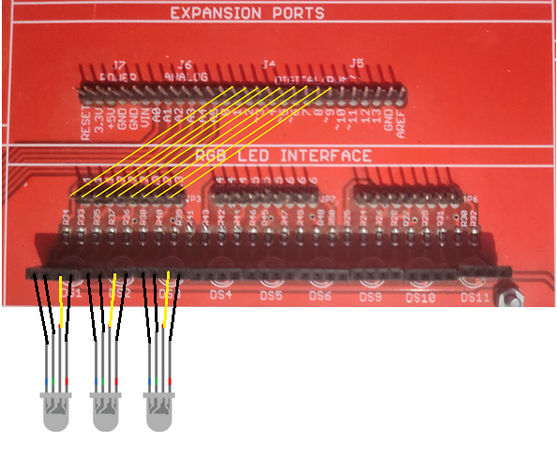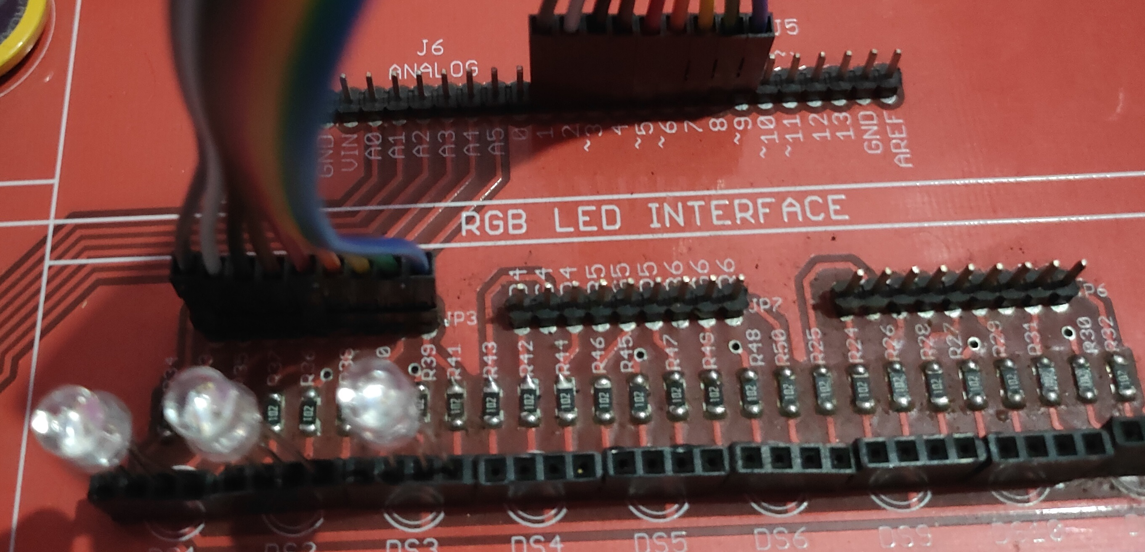

**3. ANALOG INTERFACE**

**CODE;**

//……………….KRISH_TEC…………………………..

//………………. ANALOG INTERFACE ……………

int analogInPin = A0;

int LEDPin = 13;

int sensorValue= 0;

void setup() {

Serial.begin(9600);

pinMode(analogInPin, INPUT);

pinMode(LEDPin, OUTPUT);

}

void loop() {

sensorValue = analogRead(analogInPin);

if (sensorValue>100){

digitalWrite(LEDPin, HIGH);

}

else{

digitalWrite(LEDPin, LOW);

}

Serial.println(" ANALOG INOUT = ");

Serial.print(sensorValue);

delay(1000);

}

**CONNECTION;**

Not required.

**4. BUZZER AND RELAY INTERFACE**

**CODE;**

//……………….KRISH_TEC…………….

//……………….BUZZER…………………

int BUZZER = 13;

void setup() {

pinMode(BUZZER, OUTPUT);

}

void loop() {

digitalWrite(BUZZER, HIGH);

delay(1000);

digitalWrite(BUZZER, LOW);

delay(1000);

}

**CONNECTION;**

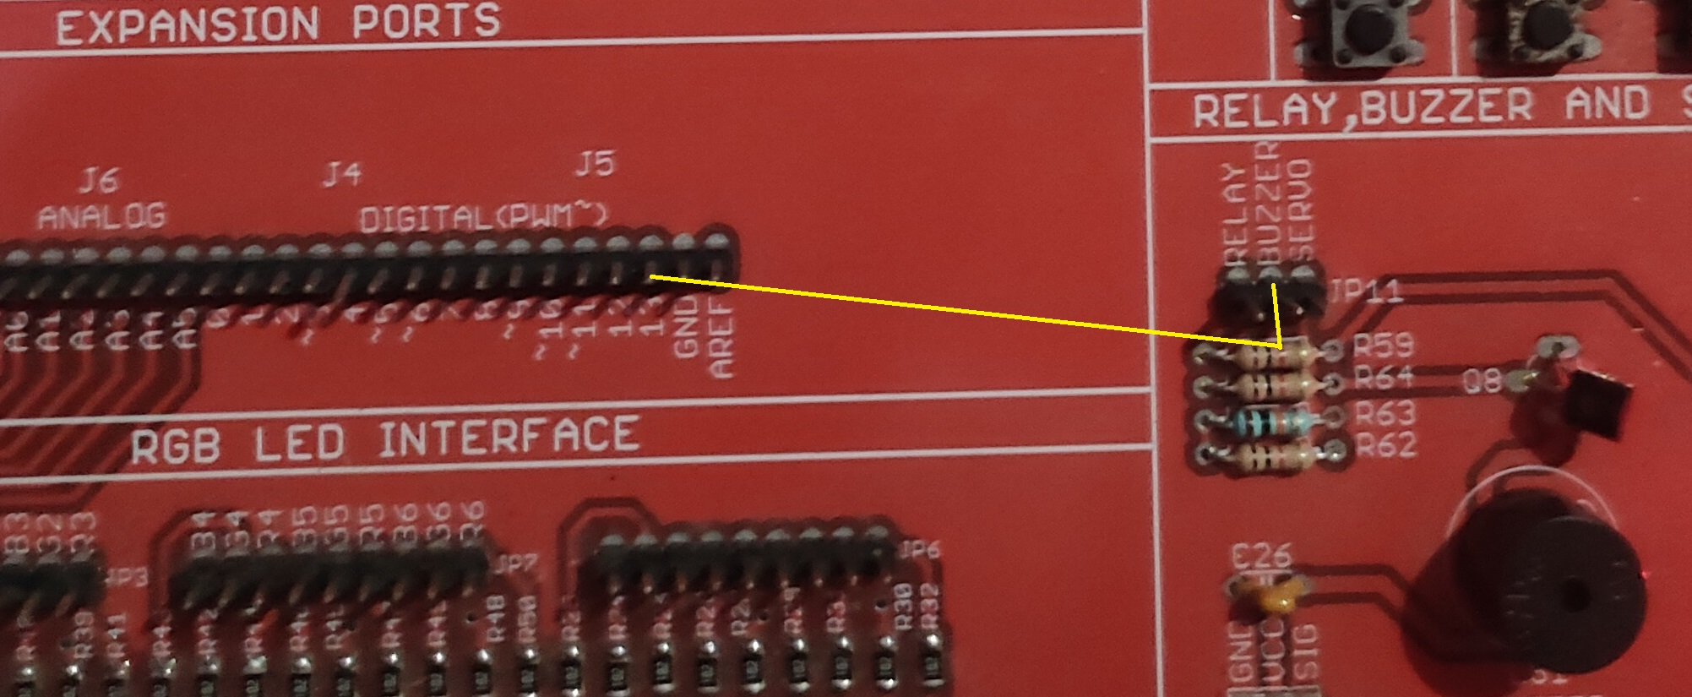

**5. KEYBOARD INTERFACE**

**CODE;**

//……………….KRISH_TEC…………….

//………………. KEYBOARD …………………

#include <Keypad.h>

const byte ROWS = 4;

const byte COLS = 4;

char hexaKeys[ROWS][COLS] = {

{'1', '2', '3', 'A'},

{'4', '5', '6', 'B'},

{'7', '8', '9', 'C'},

{'*', '0', '#', 'D'}

};

byte colPins[COLS] = {0, 1, 2, 3};

byte rowPins[ROWS] = {4, 5, 6, 7};

Keypad customKeypad = Keypad(makeKeymap(hexaKeys), rowPins, colPins, ROWS, COLS);

void setup(){

Serial.begin(9600);

}

void loop(){

char customKey = customKeypad.getKey();

if (customKey){

Serial.println(customKey);

}

}

**CONNECTION;**

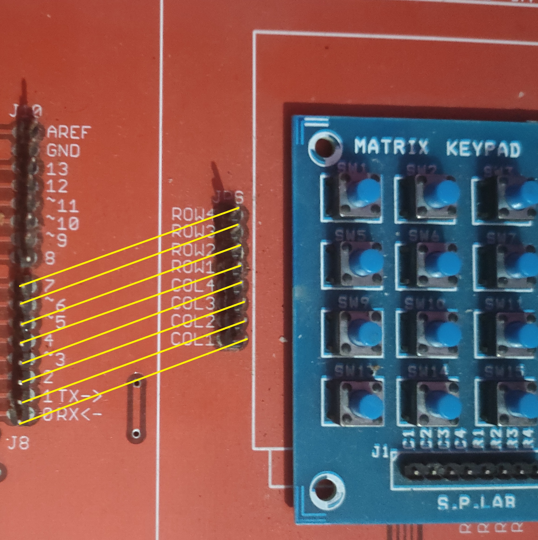

**6. LCD INTERFACE**

**CODE;**

//……………….KRISH_TEC…………….

//……………….LCD……………………….

#include <LiquidCrystal.h>

const int rs = 13, en = 12, d4 = 11, d5 = 10, d6 = 9, d7 = 8;

LiquidCrystal lcd(rs, en, d4, d5, d6, d7);

void setup() {

lcd.begin(16, 2);

lcd.print("Krish tec");

delay(1000);

}

void loop() {

for (int positionCounter = 0; positionCounter < 13; positionCounter++) {

lcd.scrollDisplayLeft();

delay(150);

}

for (int positionCounter = 0; positionCounter < 29; positionCounter++) {

lcd.scrollDisplayRight();

delay(150);

}

for (int positionCounter = 0; positionCounter < 16; positionCounter++) {

lcd.scrollDisplayLeft();

delay(150);

}

delay(1000);

}

**CONNECTION;**

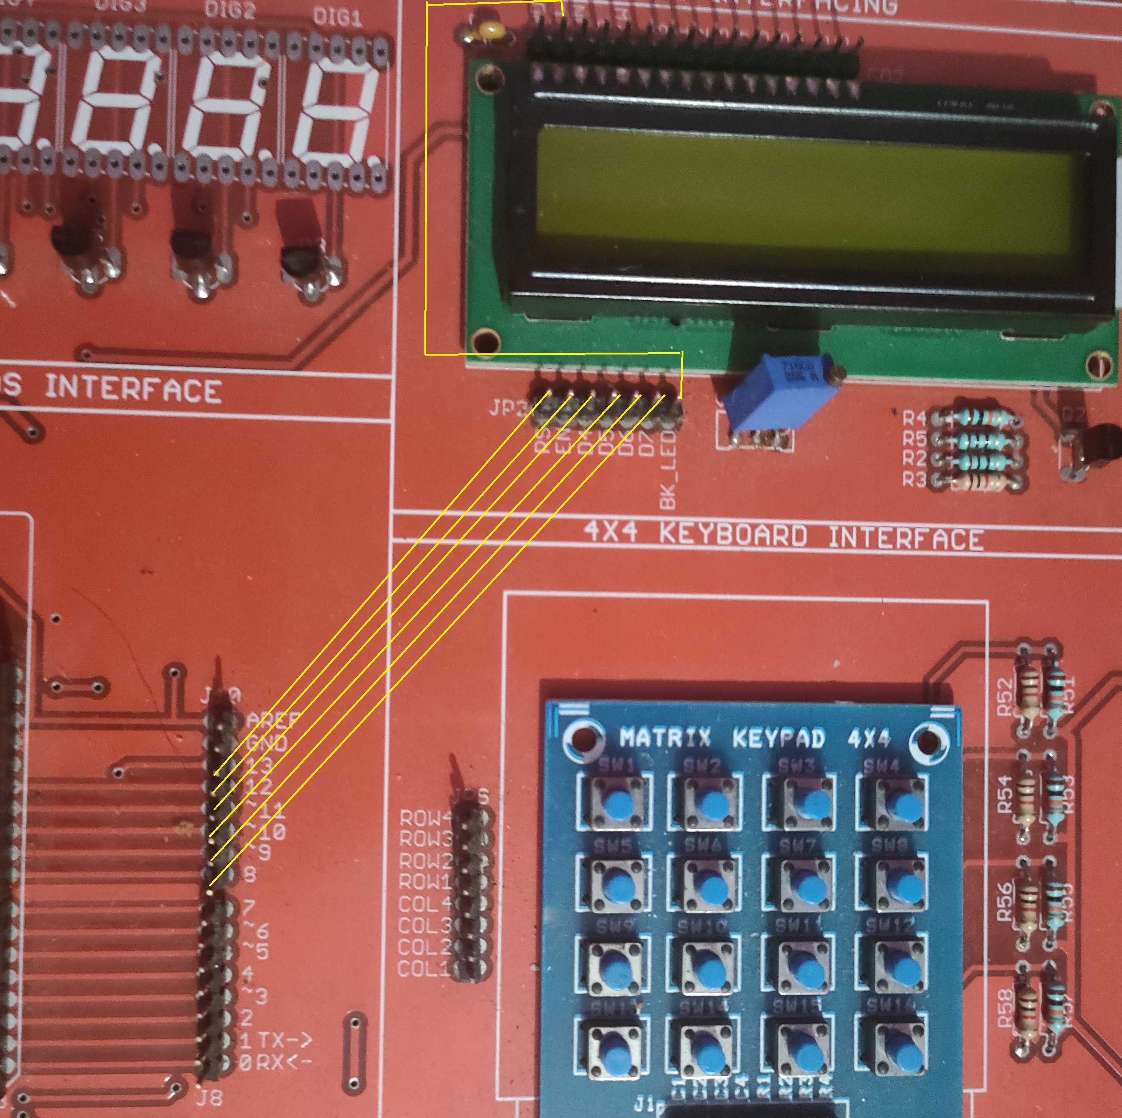

**7. LCD & KEYPAD INTERFACE**

**CODE;**

//……………….KRISH_TEC…………….

//……………….LCD&KEYPAD…………

#include <Keypad.h>

#include <LiquidCrystal.h>

const byte ROWS = 4;

const byte COLS = 4;

char hexaKeys[ROWS][COLS] = {

{'1','2','3','A'},

{'4','5','6','B'},

{'7','8','9','C'},

{'*','0','#','D'}

};

byte rowPins[ROWS] = {0, 1, 2, 3};

byte colPins[COLS] = {4, 5, 6, 7};

Keypad customKeypad = Keypad( makeKeymap(hexaKeys), rowPins, colPins, ROWS, COLS);

LiquidCrystal lcd(13, 12, 11, 10, 9, 8);

void setup()

{

lcd.begin(16, 2);

lcd.print("Krish Tec");

delay(2000);

lcd.clear();

lcd.setCursor(0, 0);

}

void loop()

{

char customKey = customKeypad.getKey();

if (customKey)

{

lcd.print(customKey);

}

}